Table Of Contents

Service Integration Accountability Model (SIAM)
for
EAPM Handbook & Checklist Guidebook

Draft

Version 0.5

April 14, 2004

Developed for:
Management Board Secretariat
Government of Ontario

Developed by:
Chartwell Inc

Introduction 1
EAPM Handbook Specification 2
Checklist Guidebook Specification 5
Service Integration Modeling and Service Accountability Modeling Guidelines 7
Elements of Service Integration and Service Accountability Models 7
Services 7
Accountable Organizations 8
Outputs and Relationships 9
Target Group Role 10
Semantic Diagrams for SIM and SAM 10
Service Modeling Conventions 12
Service Modeling Constraints 13
Service Relationship Patterns 14
Appendix A. Service Integration and Accountability Modeling Guideline Decisions 16

Introduction
This document has been produced to address the need for specifications for Service Integration Accountability Models in the EAPM Handbook and Checklist Guidebook. “How-to” guidelines for developing these models are also provided.

Appendix A lists the decisions that need to be made to finalize the specifications.

Note: This document proposes that there will be one model that specifies horizontal accountability across a group of integrated services – the Service Integration Accountability Model (SIAM). The SIAM modeling conventions provide rules for analyzing simple accountability of one service to another, and joint accountability of two or more services collaborating to serve the same end client where that situation arises.

EAPM Handbook Specification

Artifact Type: Service Integration Accountability Model (SIAM)

[Zachman Framework: Row 2, Column 2]

What /Purpose:

A Service Integration Accountability Model (SIAM) is a diagram that identifies the services that, in concert, realize the direct outcomes of a program or group of programs, and ensures their completeness by analyzing their relationships to each other and to the program’s target groups (end clients) in terms of horizontal accountability. The definition of “service” is provided in the document “Defining Programs and Services in the Ontario Public Service”.

THe SIAM analyzes the final valued service outputs meeting target group needs and identifies all intermediate outputs and the services producing them so as to ensure the highest possible degree of enterprise performance in producing the final outputs. Thus a SIAM defines the complete scope of a selected program or programs from a functional (i.e., service output) perspective. The SIAM enables the business designer to confirm that all the necessary services and service outputs for accomplishing the direct outcomes of a program have been identified.

The SIAM analyzes the collaboration among all services in scope in terms of horizontal accountability for producing and delivering all intermediate outputs required to assemble the final valued outputs. It identifies all service level agreements and performance metrics required to ensure complete accountability for service delivery and allocates or maps them to organizational structure.

The SIAM provides the basis for workflow modeling. A SIAM can be translated using a straight-forward procedure into models showing work and material flow used in other methodologies, e.g. RUP use cases and activity diagrams. The SIAM ensures consistent and leveled process integration across all organizational boundaries.

There are two forms of the SIAM: typed and implementations.

- The typed SIAM portrays service and output types, with no reference to organization structure or physical locations. The types of services can range from very abstract (e.g. Channel Service) to very specific (e.g. Ontario Driver License Counter Channel Service).
- The implementation SIAM portrays all the information of a typed SIAM plus organizational assignments for services. The services and output types must be defined with sufficient specfificity to assign each service in the model to an organization, e.g. Ministry of Consumer and Business Services Integrated Service Delivery Counter Channel Service.

As is the case for all architecture models, SIAMs may express also existing (as-is), to-be or could-be designs.

SIAM Description:

Any Service Integration Accountability Model describes a specific program or group of programs. It shows the following:
- Ellipses that name the services that deliver a program directly and support the delivery of the program.
- Arrows that indicate horizontal accountability for service delivery between services and between services and end clients (program target group members).
- Names on the arrows that define the outputs of each service, for which the service is held accountable.

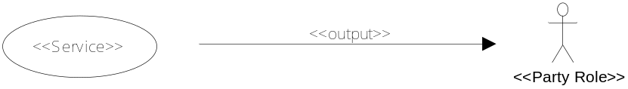

It is important to remember that the arrow in a SIAM diagram does not imply that the output is delivered or conveyed to the party indicated by the arrow, only that the service is accountable to the party indicated by the arrow. Arrows indicate the presence of an explicit or implicit service level agreement (SLA) between the parties.

The services and outputs found in a SIAM should be identified in the Zachman Framework “Services” artifact (row 1, column 2). The organizations in an implementatiojn SIAM are identified in the Party/Organization artifact (row 1, column 4).

[ Note for consideration: outputs may be better classified in column 1 of the framework as “resources”.]

Example: Typed SIAM shows simple horizontal accountability

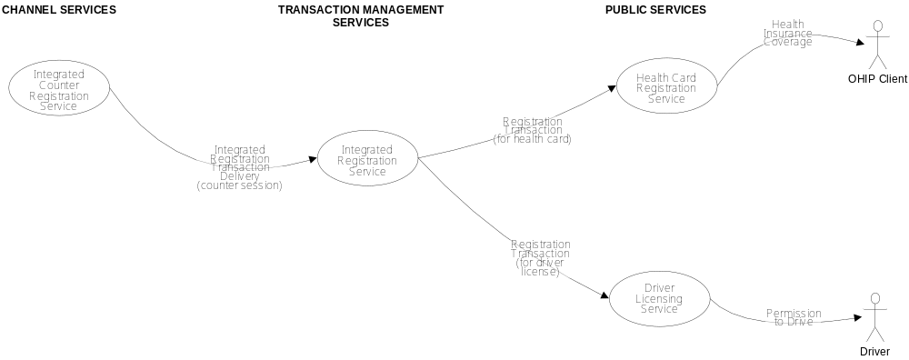

The example is interpreted as follows:
- The Integrated Counter Registration Service is horizontally accountable to the Integrated Registration Service for supplying an output called “integrated registration transaction delivery”, e.g. a counter session.
- The Integrated Registration Service is horizontally accountable to both the Health Card Registration Service and the Driver Licensing Service for supplying the output “Registration Transaction”.
- The Health Card Registration Service and the Driver Licensing Service are horizontally accountable to their respective Target Group members or end clients for issuing health insurance and granting permission to drive.

Example: Typed SIAM models joint horizontal accountability

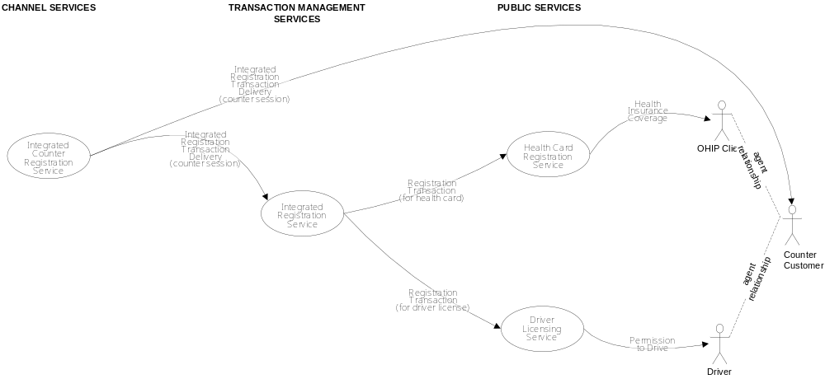

This example is interpreted similarly to the previous example of simple horizontal accountability, but also portrays the joint accountability of the Integrated Counter Registration Service with the Health Card Registration and Driver Licensing Services to the program’s target group members for some aspects of end client satisfaction. Joint accountability appears where two or more independent service level agreements (either explicit or implicit) may exist between two or more services and an end client seeking one result.

Example: implementation SIAM models organizational mapping/assignment

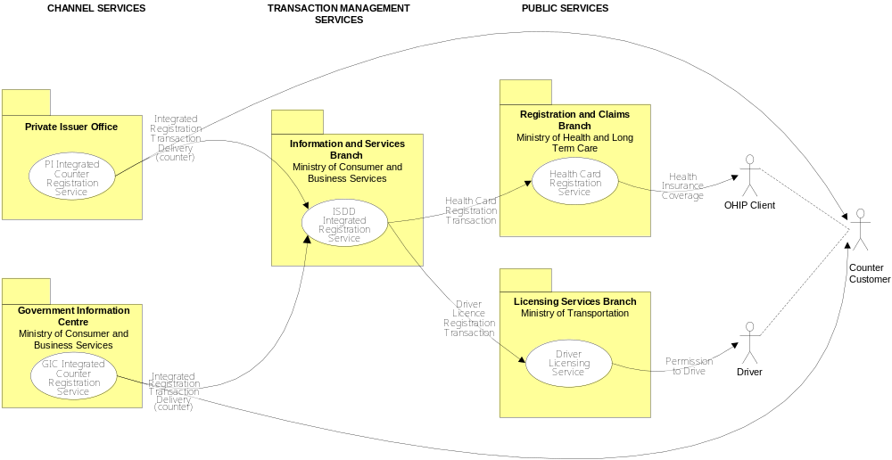

This example illustrates the mapping or assignment of organizations to services.

Checklist Guidebook Specification

Artifact Type: Service Integration Accountability Model (SIAM)

Description:

[Note: Copy from EAPM description above]

Rank:

Mandatory

Benefit:

A Service Integration Accountability Model provides the following benefits:
- illustrates the horizontal service accountabilities involved in the delivery of a program
- enables the business designer to confirm that all the necessary services and service outputs for delivering a program have been identified, and are complete and consistent from a business management perspective
- ensures that all opportunities for economies of scale arising from identification of shared processes across services can be identified and realized in the model
- promotes shared understanding of the service boundaries among all program delivery stakeholders, and of the scope of their accountabilities
- provides increased understanding of complex horizontal accountability relationships
- provides a context for development of service level agreements
- provides a context for workflow design
- enables process integration across the organizational boundaries of service providers
- enables reduction of accidental complexity with logical systems model, i.e. the divergence between business and IT systems engineering

Risk:

The following are the risks of not developing a service accountability model:
- the implementation of the services defined in a SIAM to deliver a program may not be feasible from a business management perspective if the rules for constructing a model are not followed, or if the model is not aligned with all other relevant models to determine overlaps.
- the service accountability relationships in the delivery of a program may not be properly identified, and therefore the necessary agreements in principle between stakeholders may not be appropriately established for proceeding with logical design of a change initiative
- the design of services to deliver a program:
  - may not be an optimum partitioning of processes
  - may not be complete
  - may not be feasible from an operational perspective
- the role of a service within the service value chain may not be fully appreciated, and therefore integration with other services may not be properly addressed

Service Integration Accountability Modeling Guidelines

Service integration accountability models consist of diagrams in which services, their provider organizations, the target group roles receiving service outputs and their inter-relationships are represented. There are two types of relationships, output provision and output accountability. While in most cases the two parties in the output provision and output accountability relationships that correspond to an output are the same, in some cases only one of the parties is the same (i.e. the party to which the output is provided or to which the provider is accountable).

Elements of Service Integration and Service Accountability Models

Services
Service

A service is represented in the diagram by a clear ellipse (no fill) containing the service name. By convention, the service name ends with the word “service”.

There are two types of services, provider services and public services. A public service is horizontally accountable to members of the public for service delivery, and produces outputs that meet the full needs and intentions of members of the public. A public service can in principle exist independently of all other services.

A provider service is horizontally accountable to other services for service delivery, and produces outputs that meet the needs of those other services. A provider service cannot in principle exist independently of those other services. A provider service may assume some degree of horizontal accountability to members of the public for service delivery, independently of the other services, but never the entire eccountability. Where this situation occurs it is called joint accountability with the other services.
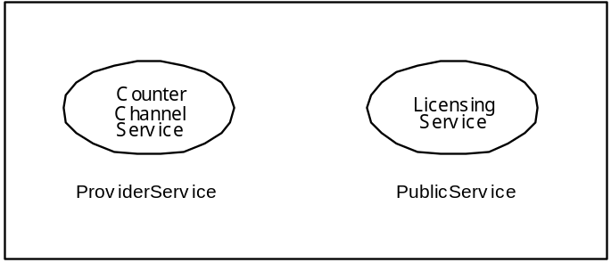

All services in a SIAM must be either at a type or implementation level. At the type level, there are various levels of abstraction at which services can be represented, e.g. channel service, counter service, counter registration service, health card counter registration service. Any service type is equivalent to a service design pattern, which may be instantiated in different ways.

Mapping organization to a SIAM produces an implementation design. An implementation SIAM is considered to have:
- Quantifiable terms of service that can be developed and published for every accountability relationship in the model
- An identifiable organization (unit, position or office) that can be assigned accountability for the service, measured by the publishable terms of service
- The service output defined to the point where it can be ordered by any qualified client and delivered on the authority of the organizational unit in accordance with the published terms of service.
- Two or more implementations of the service are considered to occur when any qualified client may arbitrarily and freely choose between them.

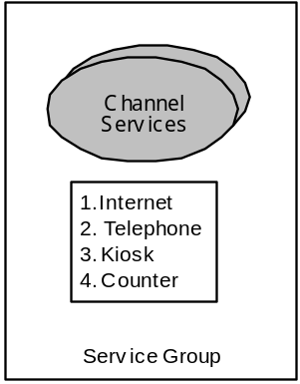
Service Group

Where a group of services in a model are of similar service types, and participate in the same acountability relationships with other services in the model, the SIAM can be simplified by grouping similar services into a service group. A service group is denoted by a shaded and shadowed ellipse with an associated list of service design instances, as illustrated above. By convention, the name of a group ends with the word “services”.

The term “service” is used hereafter to refer to either a service type, service group or serivce implementation unless a distinction must be made.

Accountable Organizations

In an implementation SIAM, a folder (UML icon package) with a name explicitly represents an organization that provides one or more services. The services provided by the organization are indicated as service ellipses within the packet icon, as illustrated below. The level of abstraction of the organizations in the model corresponds to the level of abstraction of the services.
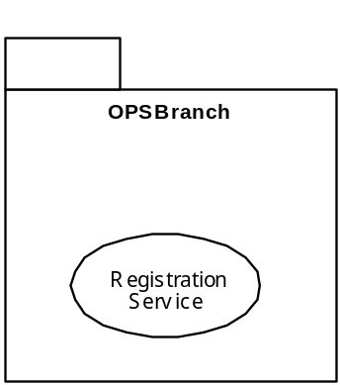

Outputs and Relationships

Outputs

Services provide a “repeatable final valued output”. Only one output type may be identified for a service. A service may produce its output in response to requests (orders) from different parties but it is always the same (repeatable) output. In the situation where the service is a group, all services included in the group must conform in the sense that their output types are valid subtypes of the group’s output type.

Accountability Relationship

An arrow called the “accountability vector” represents the accountability for the service from the service provider to the party to which they are accountable. The vector’s name is the name of the repeatable final valued output of the service.

For the accountability relationships in a SIAM, accountability vectors will always originate with a service and may terminate in either a) one or more other services or b) one or more public clients (usually shown with a figure), and in some cases both. The accountability vector originates at the service that is providing the output, and terminates at the public party or service to which the originating service is accountablt for meeting service standards for the output. The SIAM does not illustrate flow of work or material and therefore does not necessarily indicate who receives the output.

Joint Accountability

Joint accountability occurs when two or more services are involved in providing the same output to the same end client or target group and each service is to some extent independent of the others, i.e. can enter into separate service level agreements with the end client. Joint accountability is represented by two or more accountability vectors terminating in the same end client or target group member.

Target Group Role

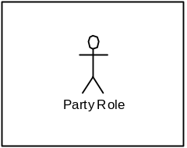
An icon figure that represents a public party in a party role to whom a public service is accountable in a SIAM.

Semantic Diagrams for SIM and SAM
The following semantic diagrams explain the key concepts underlying service integration and accountability modeling.

Public Service Manager Accountability

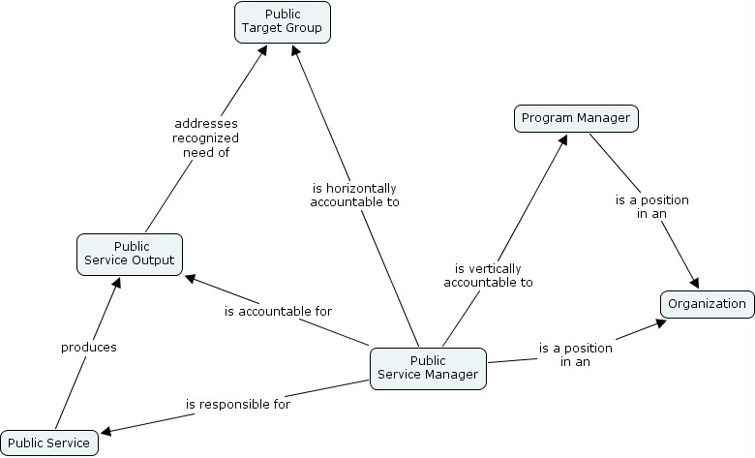

The public service manager is vertically accountable to the program manager for the efficiency and effectiveness of the service’s outputs. The public service manager is horizontally responsible to the end client or member of the public target group for the quality of the service’s outputs.

Provider Service Manager Accountability

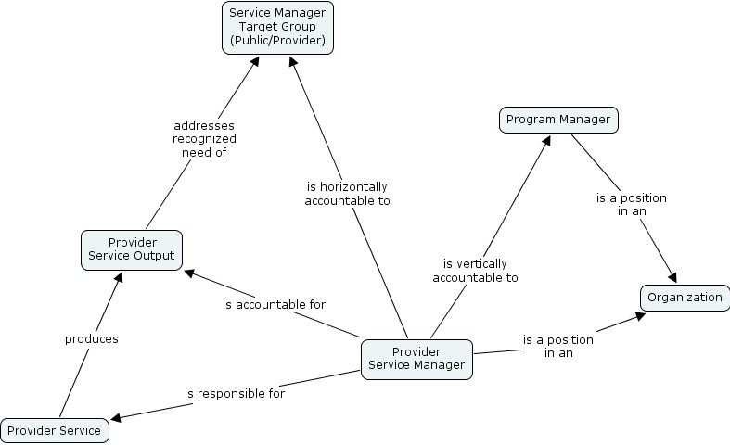

In the simplest form of provider service (a so-called shared or internal service) the provider service manager is vertically accountable to the program manager for the efficiency and effectiveness of the service’s outputs, and horizontally accountable to the managers of public and other provider services that use the service outputs for its quality.

Joint Accountability

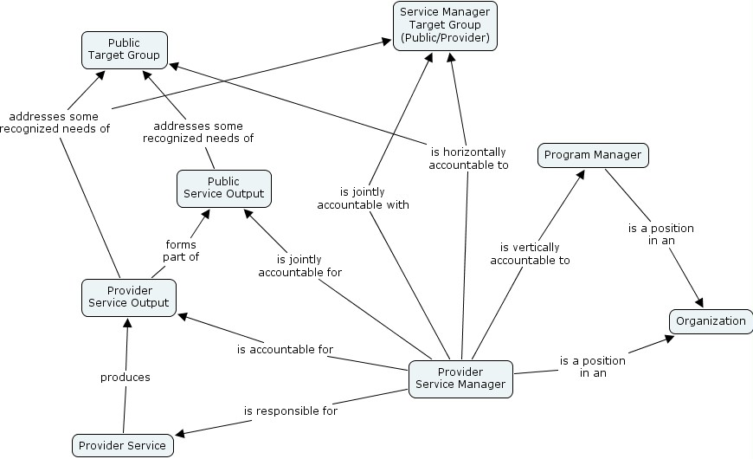

Joint accountability implies separate but linked accountabilities, brought about because the provider service output independently recognizes and addresses some needs of a public target group, but cannot be separated from the public service output that is the full intent of the public client.

Thus the provider service manager continues to be horizontally accountable to other service managers using the service’s outputs, but also becomes horizontally accountable to the public client for the provider service output. Since this cannot be separated from the public service output, the provider service manager becomes jointly accountable with those service managers who share horizontal accountability to the same public client.

Service Modeling Conventions
The following conventions apply to Service Integration Accountability Modeling:

- If a service has an accountability vector only to a public target group, then the originating service is called a public service, otherwise it is called a provider service.

- In the situation where the originating service is a service group, all included services in the group must conform in the sense that their accountability vectors terminate in the same target groups.

- By convention, at least one service in SIAM should have an accountability vector terminating in either a public target group or a generic service (with a name such as “Any Government Service”). This enables the reader to see the complete accountability chain.

- To say that service B “consumes” service A’s output, means that service A is accountable to service B for producing outputs that conform to the service level agreement between A and B, regardless of whether or not B is the recipient of the output from A.

- It is sometimes the case that a service in a model consumes its own output, or services consume the outputs of so many other services that one physical diagram becomes unwieldy. It is the modeler’s choice to represent many service relationships using several diagrams that collectively represent one model or SIAM.

Service Modeling Constraints
The following constraints apply to Service Integration Accountability Modeling:

- All services are peers.

Programs and processes observe decomposition rules – a process may be composed of smaller processes, and a program may comprise sub-programs. However, all services are peers. No service is a sub-service or super-service of any other service. Thus all SIAMs produced for the same enterprise are at the same level and can be joined up or integrated correctly.

THerefore a service is considered to contain all the processes required to produce its outputs other than those represented by other services in the same model, or by other services in other SIAM models (e.g. common services such as those of a human resources program).
- example

- Services are “machines”.

Services are treated as black boxes in any SIAM, or as a “machine”. Only outputs and accountability relationships can be expressed. All inputs to the service and all intermediate (process) outputs of the service are therefore suppressed; they will appear in more detailed models such as workflows derived directly from SIAMs.
- example

- Principle of two targets:
Service A must produce its output for two or more independent target services B and C which may appear in the same or separate typed SIAM diagrams, or for one target service D in an implementation SIAM where D will have multiple actual realizations. Otherwise service A is only a process in its target service and must be removed from the model.
- example

- Principle of target independence:
Two services are considered independent of each other in SIAM diagrams if when an accountability vector is drawn between some originating service A and two or more target services B and C, B and C can consume A independently of each other.
- example

- Principle of separation:
When a service C consumes two or more services A and B in SIAM diagrams, the assumption is that the outputs from each of A and B are separable – meaning that C can consume service A’s output independently from service B’s output. If this is not the case, then the outputs from services A and B are not separable and have some form of compound or aggregate relationship beyond C’s control. For example, if B’s output is an optional feature or addition to A’s output, then service B is really accountable to service A, and A’s output is an aggregate with optional elements.
- example

Appendix A. Service Integration Accountability Modeling Guideline Decisions

The following decisions regarding Service Integration and Accountability Modeling need to be made, so that the guidelines can be finalized.

- use of GSRM service output types
- use of GSRM service process and metric patterns book
- use of model validation table
- use of UML use cases and activity diagrams to represent flow, transformation of SIAMs

